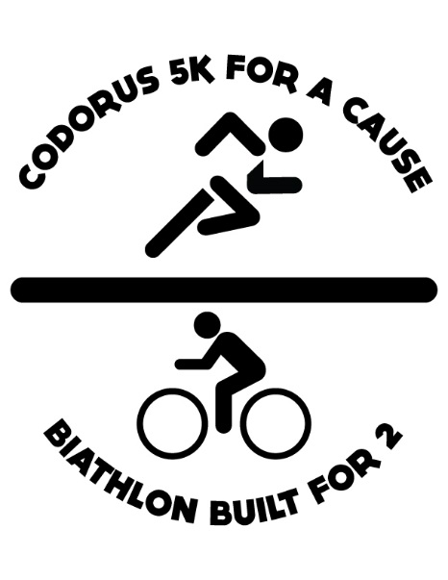
Biathlon Built for 2 and Mason Brady 5K is a fundraiser benefiting the Mason Brady Dollars for Scholars and Leiland Smith Fund

- The biathlon will take place Saturday, September 30st 2017 at 9:00 AM at Codorus State Park. The course is a 2 mile run (mostly flat), 12 mile bike around Lake Marburg (mostly not flat), and 2 mile trail run (rolling hills). The price is $50 plus processing fee per participant or $80 plus processing fee for 2 person team. Prices will increase $5 after September 15th.

- The 5k will take place Saturday, September 30th 2017 at 9:00 AM at Codorus State Park. This is a 3.1 mile trail (and some road) run. The course is well marked and volunteers will be stationed along the way to direct. There will be some mud along the trail course. The price is $30 plus processing fee per participant. The price will increase $5 after September 15th.

- Packet pick up will take place at the start location on Friday, Sept 29th, from 5- 7pm and on Saturday, Sept 30th from 8 - 8:45am. Participants must pick up their own packet, they cannot pick up for anyone else. No jogging strollers or pets will be allowed the day of the race. More information, registration, and maps of the race can be found at http://biathlonbuiltfor2.weebly.com or by contacting Rodney at 717- 965-6846 or Denise Markle at 717-965-1665.

