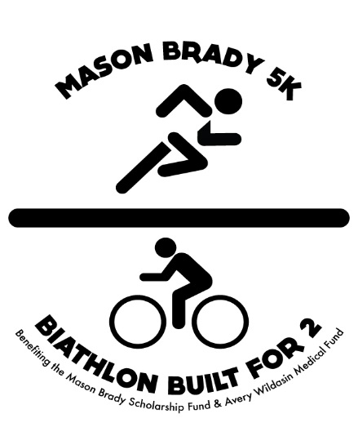
Dear Community Member:

In June 2014, the Hanover community experienced a great loss when Mason Brady, a 2010 South Western graduate, suffered a fatal car crash. Mason appreciated hard work and giving back, things he learned from our community and as a student-athlete, and he made an incredibly positive impact on the Hanover community in such a short time. Avery is a sweet one and half year old who received a diagnosis of a very rare genetic disorder called Prader-Willi Syndrome. PWS is a spectrum disorder that presents itself through several symptoms throughout a person’s lifetime. Behavioral, learning, and physical disabilities often occur that will require special care and therapy throughout Avery’s entire life. PWS affects the hypothalamus, which in turn will cause hyperphagia, a feeling of constant hunger. Avery will eventually never feel full and will need a special, structured diet. Avery is currently facing challenges with her health, as she will have surgeries in her near future of ear tubes, adenoid removal, and surgery to correct the muscles in her eyes. She continues to make strides towards growth and continues to show determination and perseverance in the face of adversity.

We are writing on behalf of the Mason Brady Dollars for Scholars Scholarship Fund and the Avery Wildasin Medical Fund to request a donation for the annual, Biathlon Built for 2 and Mason Brady 5K events, which will be held on September 29th, 2018 at Codorus State Park, Pa. The Biathlon Built for 2 is a community event where participants will challenge themselves on a two mile road run, 12 mile bike ride, and two mile trail run. The Mason Brady 5K is a 3.1 mile trail run. The money raised from the event will be awarded as a scholarship to two South Western High School students planning to attend a trade school for post-secondary education and to assist with expenses due to Avery’s PWS diagnosis.

We are asking local businesses to help assist with donations for our two causes and encourage participation. Monetary donations, gift certificates, prizes, snacks, and drinks are all great ways to support the local event. We expect to have approximately 150 participants this year.

Mason and Avery’s family have given so much of themselves to our community and this is our opportunity to pass our gratitude and support back. Please seriously consider this request and let your neighbors, your customers, and your community know about the event, which will build relationships within the community while supporting two meaningful causes. If you would like more information about the Biathlon Built for 2 or Mason Brady 5K, please visit http://biathalonbuiltfor2.weebly.com. Please see the back of this sheet for sponsorship advertising options.

Thank You for Your Support,
The Biathlon Built for 2 and Mason Brady 5K Committee

Biathlon Built for 2 and Mason Brady 5K Donation Form
Name/Company: ______________________________________________ Phone Number: __________________________
Address: _____________________________________________________________________________________________________
City: ________________________________________ State: _______ Zip: _____________
Email Address: ________________________________________________________________
How you would like to contribute:
Monetary Donation Amount: _$_____________________Please make checks payable to Biathlon Built for 2 c/o Randy Brady, PO Box 745, Hanover PA 17331
List other form(s) of contributions here: _________________________________________________________________
*Please keep a copy of this as your tax receipt. **See back for prices

Advertising Options:

- Start/Finish Line Banner:
1 sponsor on banner - $1,000
2 sponsors on banner - $500 per sponsor
4 sponsors on banner - $250 per sponsor

- Mile Marker Advertisement (appx 18x24) - $100

- Name on t-shirt – minimum $100 donation

